Solidarity with Prisoners on Hunger Strike in Turkey
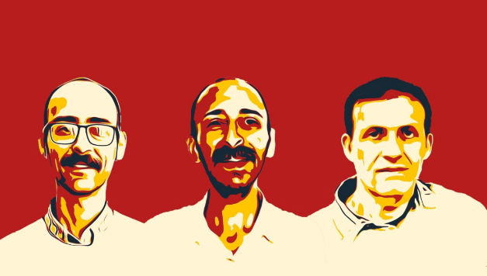
In 2021, new types of prisons were quietly introduced in Turkey.

They are known as S-, R-, and Y-type prisons.

Prisoners call them “pit-type prisons” — as if they’ve been thrown into a pit with a lid shut on top.

This marks another chapter in a long history of violations stemming from inhumane prison conditions in Turkey.
However, the situation has become especially critical for several prisoners who are on long-term hunger strikes and have now reached life-threatening conditions.
These prisoners are demanding to be transferred out of the so-called S-, Y-, or other high-security prisons, where their rights are routinely violated. They are subjected to prolonged deprivation of fresh air, sunlight, physical activity, and human contact.

Urgent Case 1:
As of 26 October 2025, Serkan Onur Yılmaz will have been on hunger strike for an astounding 350 days. Initially held in the high-security prison in Antalya — notorious for its inhumane conditions of isolation — he was later transferred to Bolu F-type prison following his prolonged hunger strike.
Since eight of his former fellow prisoners remain under the same conditions, he has chosen to continue his protest, turning it into a death fast in an effort to secure their transfer as well.
He is now in a critical, life-threatening condition and could die at any moment.

Urgent Case 2:
The second of 16 prisoners currently on hunger strike or death fast is Ayberk Demirdögen.
He has been on a death fast since 11 March 2025 — a total of 230 days — and is also in an extremely fragile state. Like others, he was transferred from a prison with harsh isolation to Kırıkkale F-type prison.
He continues his strike in solidarity, demanding transfers for his fellow inmates.
Urgent Case 3:
Fikret Akar has been on an indefinite hunger strike for 211 days. In February, he was transferred to Karatepe high-security prison in Çorlu, where he is being held under severe isolation — conditions he describes as unbearable.
He demands to be moved to a facility with humane standards.
Turkey is attempting to silence revolutionary prisoners.
Let’s not leave them alone.
You can show your solidarity with just a signature.
Scan the QR codes to sign the petition.

The demands of the hunger-striking prisoners must be met.
The pit-type prisons must be shut down.
📧 Write to us: is4pp@riseup.net
🌐 Follow us: is4pp.org
📱 TikTok: @is4pp6 | Instagram: @is4pp202

